# Software 2 Theory Lecture 7 Algorithms for Graphs

Graph terminology:

* Walk -> (A sequence of vertices…) moving from vertex to vertex, following edges, starting at v0 and ending at vk, the length is the number of edges used.
* Path -> (A walk where all the vertices are distinct…) Cannot return to the same vertex again, so all edges and vertices must be different from each other

## Number of paths

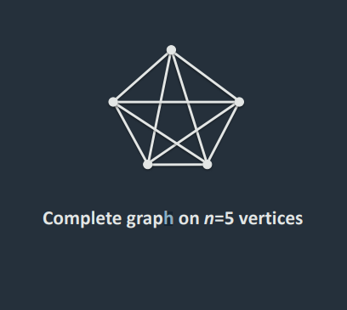The number of walks and paths depends on the graph, but in a **complete graph** (where there is an edge between all pairs of edges).

Any sequence of vertices starting at u and ending at v is a walk – so there is an in**finite amount of walks**.

Any sequence of vertices starting at u, ending at v and of length k+1 is a walk of length k, so there are n­­k-1­ such walks.

For a **path**, there are n-2 choices for the second vertex, n – 3, for the third etc… so the number of paths is:

(n-2)(n-3)…(n-k) = (n-2)! / (n-k-1)! – the number of walk and paths is potentially exponentially large.

## Shortest Path

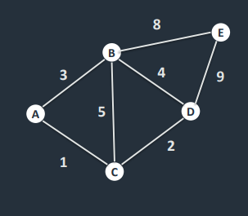This is a weighted graph, with the numbers representing the lengths of edges. The length of a walk (path) is the sum of the edge lengths used.

How can we find the shortest path between two vertices among all possible paths?

Notation: let sp(u,v) be the shortest path between u and v, and l(sp(u,v)) be its length.

Key property of shortest paths, If 𝑤 ∈ sp(𝑢, 𝑣) then 𝑠𝑝 𝑢, 𝑣 = 𝑠𝑝 𝑢, 𝑤 + 𝑠𝑝(𝑤, 𝑣) – (meaning pick the shortest path between each pair of nodes for each step).

## Dijkstra’s algorithm

An algorithm for finding the shortest different between two paths.

(Paths can be represented in a table)

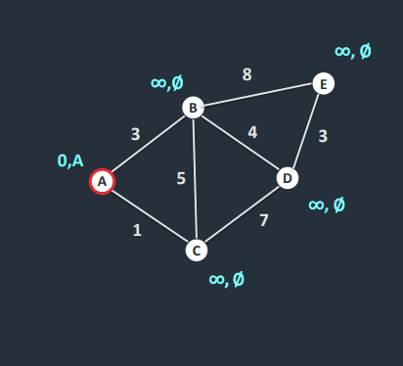 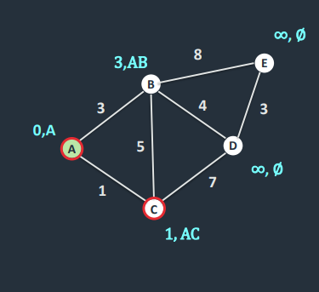

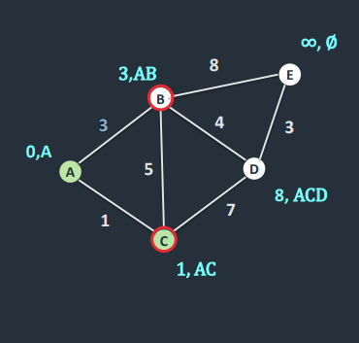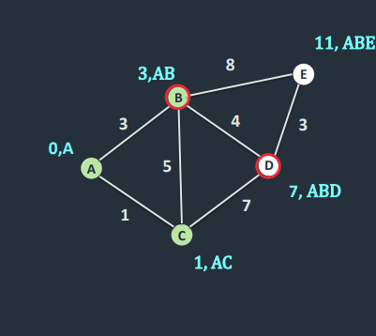

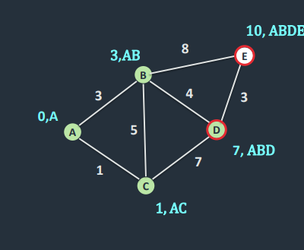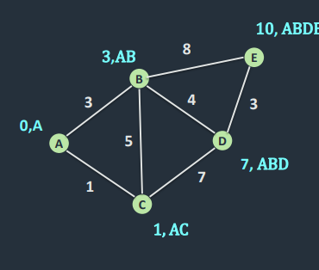

Dijkstra’s algorithm is a single-source alldestination method. The complexity is O(n2).

For all-source all-destination shortest paths, the Floyd-Warshall algorithm can be used which is O(n3).

## The A* Search

The A* star search algorithm also finds the shortest path between two points, it does this in a more efficient way than Dijkstra’s algorithm using heuristics – by using the sum of the actual value and the heuristic value (see problem set).

## Spanning Tree

A spanning tree of a graph is a tree which includes all vertices and uses only edges in the graph – so essentially the graph has no cycles. All connected graphs have at least one spanning tree.

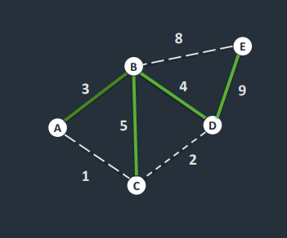(Since a spanning tree is a tree, it has exactly n-1 edges, and uses the minimum number of edges to connect all the vertices)

This tree has a weight w(T) of 21.

In a weighted graph, the minimum spanning tree is the tree with the smallest weight.